|  |  |
| --- | --- |
| **"Sleep Apnea And Cpap"** | **search title :-** |
| 1. **Mohamed Abdo Ali** 2. **Sara Younis** 3. **Asmaa Ibrahim** | **Preparation by :-** |
| **Dr/ Mohamed Nagy** | **Supervisor:-** |

**Elements of the subject:-**

1. **What is sleep apnea?**
2. **What is the hypopnea?**
3. **What are the 3 types of sleep apnea?**
4. **How Common is Sleep Apnea**
5. **Apnea–hypopnea index**
6. **What are causes?**
7. **What are symptoms?**
8. **What are risks of this is disease?**
9. **Treatments of disease.**
10. **Breathing signal**
11. **What is CPAP?**
12. **Auto cpap ,BiPAP and difference between them and cpap**
13. **Modes in cpap**
14. **Uses of CPAP.**
15. **Component of CPAP**
16. **Mechanism of CPAP.**

**Introduction:-**

**Sleep apnea is a sleep disorder in which pauses in breathing or periods of shallow breathing during sleep occur more often than normal. Each pause can last for a few seconds to a few minutes and they happen many times a night. In the most common form, this follows loud snoring. There may be a choking or snorting sound as breathing resumes. Because the disorder disrupts normal sleep, those affected may experience sleepiness or feel tired during the day. In**

**children it may cause hyperactivity or problems in school**

**cpap** **Continuous positive airway pressure (CPAP) is a form of positive airway pressure (PAP) ventilation in which a constant level of pressure above atmospheric pressure is continuously applied to the upper airway. The application of positive pressure may be intended to prevent upper airway collapse, as occurs in obstructive sleep apnea, or to reduce the work of breathing in conditions such as acute decompensated heart failure.**

**What is sleep apnea?**

**is a sleep-related breathing disorder that involves a decrease or complete halt in airflow despite an ongoing effort to breathe. Duration of sleep apnea at least 10 seconds**

**What is the hypopnea**

**Hypopnea is a partial blockage of the airway, and is a feature of a condition called obstructive sleep apnea hypopnea syndrome.** **A hypopnea is a decrease in airflow by at least 50% for ten seconds or more, with a 3% desaturation of blood oxygen level.**

**What are the 3 types of sleep apnea**

**Obstructive sleep apnea (OSA): OSA occurs when the airway at the back of the throat becomes physically blocked. That obstruction causes temporary lapses in breath.**

**Central sleep apnea (CSA): CSA happens because there is a problem with the brain’s system for controlling muscles involved in respiration, leading to slower and shallower breathing.**

**Mixed sleep apnea: When a person has both OSA and CSA at the same time, it is referred to as mixed sleep apnea or complex sleep apnea**

**What is the Common in Sleep Apnea types**

**Obstructive sleep apnea is estimated to affect between 2-9% of adults.** **in the United States, but many cases are believed to go undiagnosed** **Central sleep apnea has been found to affect around .9% of adults5 over the age of 40. It is found much more frequently in men than in women**

# **Apnea–hypopnea index**

# 

**It is represented by the number of** [**apnea**](https://en.wikipedia.org/wiki/Apnea) **and** [**hypopnea**](https://en.wikipedia.org/wiki/Hypopnea) **events per hour of sleep. The apneas (pauses in breathing) must last for at least 10 seconds and be associated with a decrease in blood oxygenation**

**The AHI is calculated by "dividing the number of apnea events by the number of hours of sleep". The AHI values for adults are categorized as:**

* **Normal: AHI<5**
* **Mild sleep apnea: 5≤AHI<15**
* **Moderate sleep apnea: 15≤AHI<30**
* **Severe sleep apnea: AHI≥30**

**What are causes**

**Obstructive sleep apnea occurs when a person’s airway becomes blocked during sleep. Multiple factors have been found to increase the risk of blockage**

**Anatomical characteristics. The size and positioning of a person’s neck, jaw, tongue, tonsils, and other tissue near the back of the throat can directly affect airflow.**

**Use of sedatives including alcohol. Sedative medications and drugs can cause tissue in the throat to relax, making it easier for the airway to become obstructed.**

**Family history. People who have one or more close relatives with OSA are more likely to develop OSA themselves.**

**Sleeping on your back. This sleeping position makes it easier for tissue to collapse9 around the airway and cause blockages.**

**Nasal congestion. People whose ability to breathe through the nose is reduced because of congestion are more likely to experience OSA.**

**What are symptoms**

**All three types of sleep apnea share certain common symptoms:-**

**1- Disrupted breathing in which a person’s respiration can become labored or even stop for up to a minute at a time**

**2-** **Excessive daytime sleepiness**

**3-** **Morning headaches**

**4-** **Irritability**

**5-** **Limited attention span or difficulty thinking clearly**

**Some additional symptoms are connected to obstructive sleep apnea:-**

**1-Snoring, including snoring that is especially loud and involves gasping, choking, or snorting that may cause a person to briefly wake up**

**2-** **Morning sore throat or dry mouth**

**3-** **Frequent need to wake up to urinate**

**What are risks of this is disease**

**Sleep apnea can affect anyone at any age, even children. Risk factors for sleep apnea include: -**

**Being male --** **Being overweight—**

**Being over age 40 --**

**--Having large tonsils, a large tongue, or a small jaw bone**

**Having a family history of sleep apnea—**

**Treatments of disease 8-**

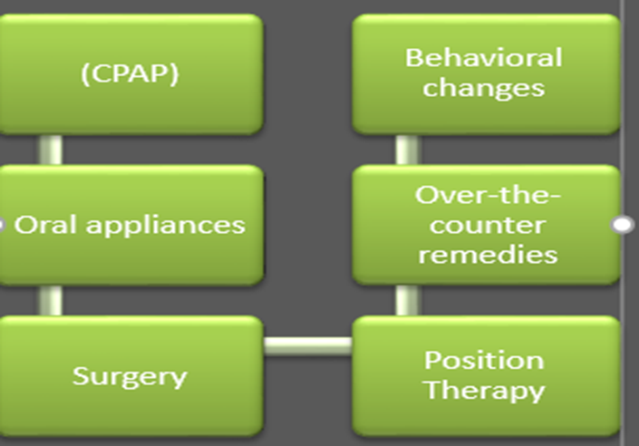

**breathing signal o0f sleep apnea**

**To score an apnea on a** [**sleep study**](https://singularsleep.com/pages/sleep-apnea-test-home-study) **there must be essentially no airflow (measured through a** [**nasal pressure senso**](https://singularsleep.com/blogs/news/home-sleep-apnea-test-guide)**r or thermistor) for at least ten seconds A blood oxygen drop, known as an oxygen desaturation, is not part of the criteria for an apnea. There are three different types of apneas described in this manual**:

#### **Obstructive Apneas**

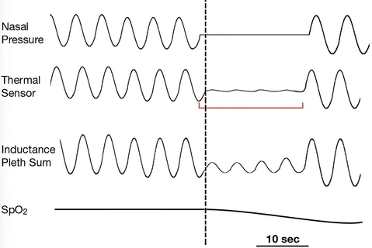

" **Basically, there is TOTAL upper airway obstruction resulting in no airflow (the nasal pressure and/or thermistor sensors show no signal) but respiratory effort is sustained (the chest [**[**RIP**](https://singularsleep.com/blogs/news/home-sleep-apnea-test-guide)**] belt signal is maintained), meaning that you are trying to breathe**. "

#### **Central Apneas**

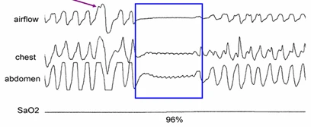

#### " **With a central apnea, there is complete absence of both airflow and respiratory effort. In essence, your brain has "forgotten to breathe**."

#### **Mixed Apnea**

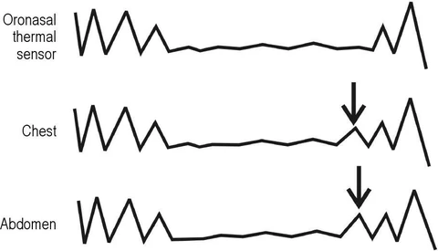

**" Mixed apneas are a hybrid of central and obstructive apneas. In the initial part of a mixed apnea, there is neither airflow nor breathing effort, but effort begins in the latter part of the episode. "**

## **Hypopneas**

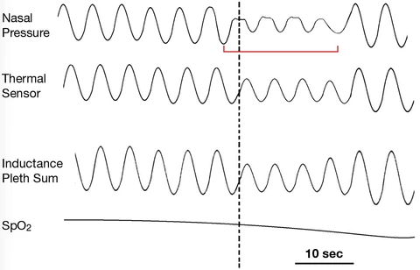

**What is cpap**

**continuous positive airway pressure (CPAP) units These units are also called:**

**" continuous positive pressure breathing (CPPB) "**

**Nasal continuous positive airway pressure (CPAP) therapy is a nonsurgical treatment that provides a steady flow of air to the lungs through the nose. Nasal CPAP is a common treatment for those with obstructive sleep apnea**

**Auto cpap and difference between it and cpap**

**AutoCPAP** **– Automatic titrating (measuring and adjusting) continuous positive airway pressure**

**this machine APAP. Unlike CPAP which is set to deliver one continuous pressure, APAP is set within a high- and low-pressure range for the purpose of varying inhalation needs. The range is predetermined by your prescribing physician. APAP has a sensitive algorithm technology that allows the machine to detect how much inhalation pressure you need with each breath**.

**BIPAP**

**"** BiPAP stands for BiLevel Positive Airway Pressure **"**

**This method delivers two distinct air pressure levels into the mask: one for inhalation and one for exhalation. Normally the inhalation is set a little higher than the exhalation, giving the patient less pressure to breathe against during exhalation periods. This dual system is ideal for those with higher pressure needs, as the two settings can provide the levels needed to alleviate apneas while still making it comfortable to exhale after each breath. After the exhalation periods, BiPAP machines will “wait” for the patient to start inhaling before they make the switch to the inhalation setting, and vice versa. Like APAP, BIPAP uses algorithms to respond to breathing patterns with changes in pressure. Because of its fast response times and high level of adaptability**,

[**BiPAP S/T**](https://repap.com/shop?olsPage=t%2Fasv)

**stands for BiLevel Positive Airway Pressure Spontaneous/Timed Therapy. The Spontaneous/Timed designation refers to mode options which allow for more complex algorithms to initiate pressure changes. BiPAP S/T will initiate inhalation by triggering IPAP either spontaneously or at fixed time intervals, depending on the settings. This type of machine actually assists impaired breathing, and can be very useful for patients with central sleep apnea or mixed sleep apnea (combinations of both obstructive and central apnea), as well as for patients with respiratory insufficiencies, restrictive lung disorders, severe COPD and hypoventilation syndromes**.

**BiPAP ST-A**

**machines include advanced assistance features that allow for either patient-initiated breaths or machine-initiated breaths. These systems include a set tidal volume for inhalation and will sound alarms in the case of halted or limited breathing. This type of non-invasive ventilation (NIV) adapts in real time to changes in breathing, using backup rates as a standard baseline for each patient**.

**Mode Terms**

**S (Spontaneous) Mode: In Spontaneous Mode the device will initiate IPAP spontaneously when flow sensors detect inspiratory changes. shifting to a higher level of pressure every time a breath is taken, and cycling back to EPAP for a lower level of pressure during exhalation.**

**T (Timed) Mode: Timed Mode refers to the timing of IPAP/EPAP intervals, meaning that each cycle is initiated by the machine, typically expressed in breaths per minute (BPM). With BiPAP in Timed Mode, the switch between inhale and exhale pressures can help to initiate breaths.**

**S/T (Spontaneous/Timed) Mode: Like Spontaneous mode, S/T Mode switches to IPAP based on patient inspiratory effort. But in Spontaneous/Timed Mode a “backup” rate is also set to ensure that patients still receive a minimum number of breaths per minute. This backup rate is based on a patient’s baseline of normal, healthy breathing. Thus, if spontaneous breaths are not taken regularly, the ventilator will initiate breaths.**

**AC (Assist Control Mode): This mode allows either patient-initiated breaths or machine-initiated breaths and includes a set tidal volume for inhalation**

[**AVAPS**](https://repap.com/shop?olsPage=t%2Fventilators) **(Average Volume Assured Pressure Support): AVAPS automatically adjusts pressure based on variations in inspiratory airflow to ensure a fixed target volume. AVAPS has shown considerable long-term benefits in patients with chronic respiratory issues as well as sleep apnea.**

[**IVAPS**](https://repap.com/shop?olsPage=t%2Fventilators) **(intelligent Volume-Assured Pressure Support): A trademark of ResMed, iVAPS uses a highly intelligent algorithm to provide pressure support that stabilizes breathing volumes**.

**Uses of Cpap**

**CPAP units are commonly used to :-**

**&& provide breathing assistance to patients with obstructive sleep apnea (OSA) or sleep apnea**

**&& CPAP also may be used to treat pre-term infants whose lungs have not yet fully developed**

**&& use CPAP in infants with respiratory distress syndrome. It is associated with a decrease in the incidence of bronchopulmonary dysplasia. In some preterm infants whose lungs have not fully developed, CPAP improves survival and decreases the need for steroid treatment for their lungs**

**&& CPAP units used as preventive and support device for patients with other diseases, such as acute asthma, congestive heart failure, cardiogenic pulmonary edema, cystic fibrosis, and chronic lung disease (CLD)**

**component of Cpap.**

**CPAP devices consist of**

**a flow generator or “blower” a length of tubing**

**a tight-fitting face mask**

**nasal mask or nasal nares**

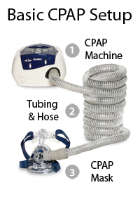

**Mechanism of Cpap**

**CPAP therapy uses machines specifically designed to deliver a constant flow of pressure. CPAP is the most effective treatment for obstructive sleep apnea, in which the mild pressure from the CPAP prevents the airway from collapsing or becoming blocked. It is an alternative to positive end-expiratory pressure (PEEP). Both modalities stent the lungs' alveoli open and thus recruit more of the lung's surface area for ventilation, but, while PEEP refers to devices that impose positive pressure only at the end of the exhalation, CPAP devices apply continuous positive airway pressure throughout the breathing cycle. Thus, the ventilator itself does not cycle during CPAP, no additional pressure above the level of CPAP is provided and patients must initiate all of their breaths**

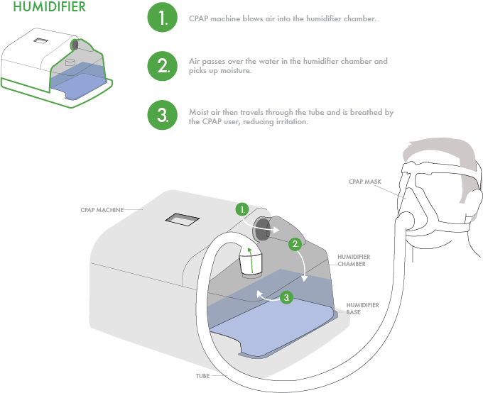

**Conclusion**

Obstructive sleep apnea is a health hazard and usually affects middle-aged, overweight adults. It causes not only snoring but also repeated obstruction to breathing while the person is sleeping. This leads to a drop in oxygen saturation within the blood which can damage organs such as the heart and the brain; however, a more advanced condition may require to use an equipment like CPAP. Treatment improves a person’s overall health by improving the quality of sleep.

We found differences between types of PAP "CPAP, APAP.BIPAP

All types using in Specific case According to the patient's condition

**References**

**1-** **Updated August 21, 2020 ___ Eric Suni**

[**https://www.sleepfoundation.org/sleep-apnea**](https://www.sleepfoundation.org/sleep-apnea)

**2-** **Strohl, K. P. (2019, March). MSD Manual Consumer Version: Sleep Apnea. Retrieved July 21, 2020, from**

[**https://www.merckmanuals.com/home/lung-and-airway-disorders/sleep-apnea/sleep-apnea**](https://www.merckmanuals.com/home/lung-and-airway-disorders/sleep-apnea/sleep-apnea)

**3-** **. National Institute of Neurological Disorders and Stroke (NINDS). (2019, March 27). Sleep Apnea Information Page. Retrieved July 21, 2020, from**

[**https://www.ninds.nih.gov/Disorders/All-Disorders/Sleep-Apnea-Information-Page**](https://www.ninds.nih.gov/Disorders/All-Disorders/Sleep-Apnea-Information-Page)

**4-ECRAI**

**5- February 20, 2017 --Joseph Krainin**

[**https://singularsleep.com/blogs/news/ahi-sleep-apnea-test**](https://singularsleep.com/blogs/news/ahi-sleep-apnea-test)

[**https://repap.com/cpap-modes-explained**](https://repap.com/cpap-modes-explained) **6-**